1 | Where and how to show meter counter in site it is per item like the comment would have a counter like we are doing now,  i.e LIKE has a counter like we are doing it now.
2 | Mute friend functionalities, where to show mute friend button? When you right click on that friend,  we can have an item to mute all notifications from that friend. See FB
3 | User can report abuse for any unknown users ? Also right click on that user, an item should show to report that user  with a comment box to why he is abusing
4 | follow of the comment for each post ?? like FB
5 | Use Create Account icon when the member is done, Use Create Account icon when the member is done filling the page rather than  the Verify icon you are using now.
6 | Notice the progress timing that hold more information about the section. The one on the top that show each page that was  completed e.i signup, profile, interest, photo, done
7 | On User wall, if birthdate/mobile/email is empty then it display blank or not to display No display

Please look into the way the logo blue bar icon for travfeed look on the Mobil screen. As of now they are taking like four raw

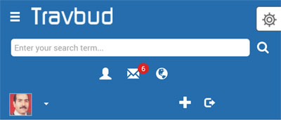



Top of Form
Please remove the following from the basic information
Home Town
Political View
Religious

Modify the following
Mobil to include country code pre set after they select the country.
City, allow for auto select which will include state and county which we can extract the state and country once needed from the that city entry. As shown below in the signup screen
Current Location, allow for auto select
Birth date, modify the menu as discussed earlier or as shown below
Language, allow selection for most language.
Edition, interest and occupation, allow for auto select. As shown below in the signup screen.

For the Photo section, please follow the given earlier instruction.
As shown below in the signup screen

Under the security section
Please Note the is done for example,
Security Question set your security question Only Me edit
Lookup Setting Who can lookup me? Friends edit

When you run edit, then the set value should show as shown in the image. Not just just the security image>>>>

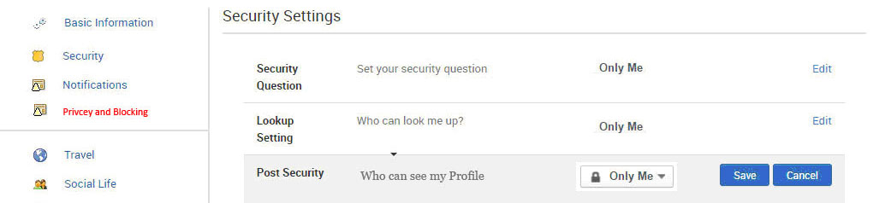

Please use the same all over the site for security either “Private” or “Only Me” because sometime we are using either “Private” and some time we are using “Only Me”

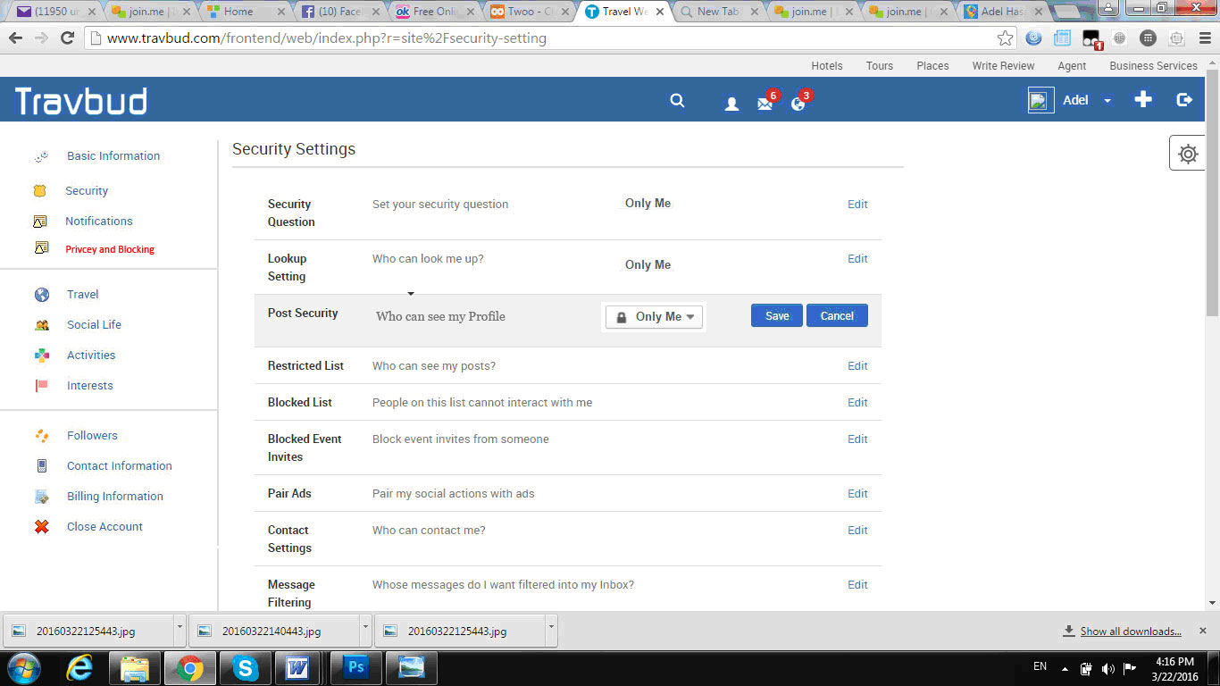
Password Reset

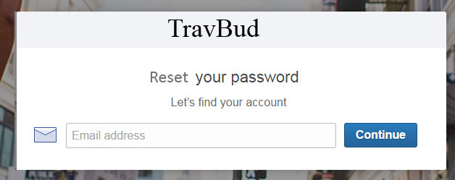

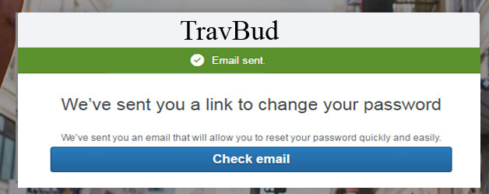

When the user click on the link, they should get a password screen to add there new password and confirm it.

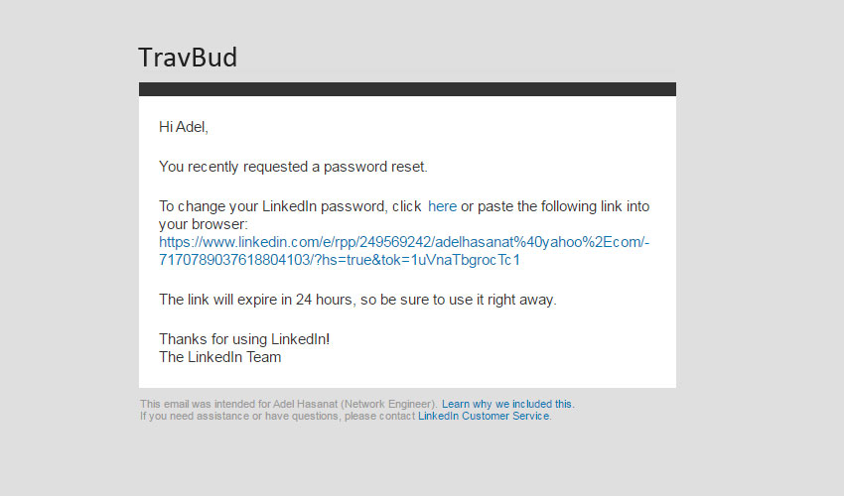
Use the dark blue to replace the light blue and make the default.



Review the add friend drawing and make it exatly like it showing below notice the border, the image size, the user name font and the add line for Mutual friend.

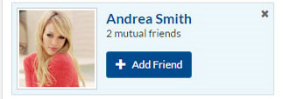

Use the progress time as shown below under the blue bar on each page, check twoo.com or youtube.com they have something similar. Use orange or yellow color for the line when runong the progress timer. Also make sure the logo bar is around 40-45 pixels high

Enlarge the + sign couple pixals on each side
There is an icon for the account setting between the + sign and the Adel next to thumbnail on the logo bar to replace the tiny arrow.



Please bring back the old menu under the + sign and take out the bookmark just keep the Saved Content.

Add about 3 pixels spacing between alert icons and also between the search icon, reduce the red circle icon size by couple pixals also put the red circle to side of the alert icons as shown below.

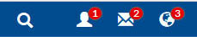 the way we would it to look

 the current look

When loading an image in the posting Tool Box please use the following method as shown in the couple images while the Post icon is dim out until the image is completely loaded then the Post icon is available for the user to click on it and post the image. Notice I took out the side borders and the tool box expand as needed while loading the image and text, it looks good. Please allow for more than one image addition in any post

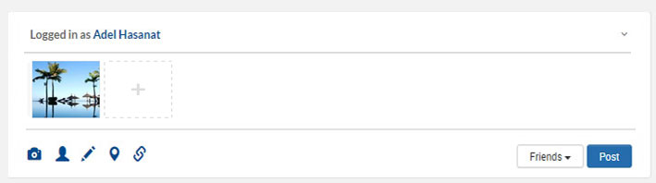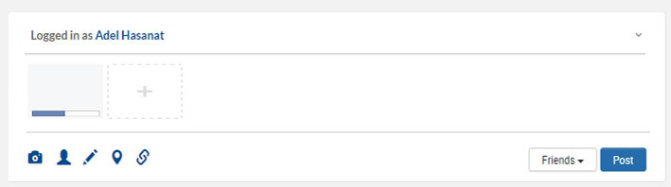

Hide Post menu item is no longer showing under the post menu, please add it back and check it to work after you hide a post and then refresh the page to see if it is still hidden.

Show the Comment count or the Share count the same you show the LIKE count plz

The loaded photos are shrinking when loaded a post before it used to expand based on the pixel count and photo size.

The image has Pinit when highlighted, please post the images in the garalery on the wall rather than going to pinit.com

Make logged in as username on top of the posting Tool Box... to be the Full Name i.e “ Logged in as Adel Hasanat” also on the Comments

Check the delete item if it works after we refresh the screen

Display three comments and then use the previous and more link to navigate between any post comments
Also notice the way the comment are display where the commenter name on left side and the comments are lined on right, Please Use the Full name not Just the first Name when showing the comment owner.

_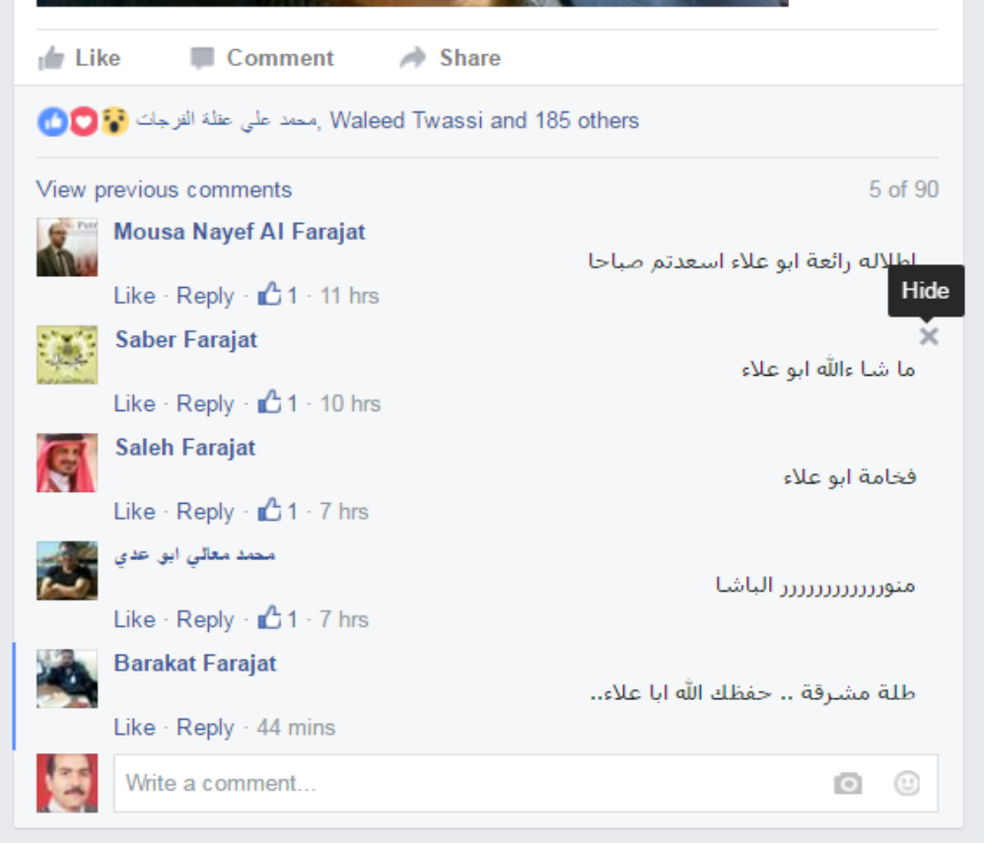

Notice the way comment are on the right hand side and the user names are on the left hand side and who things are space out correctly and are elegant.
When a member click on Share then a popup screen (not a new window) with all the option for the user to select from as shown below from FB. No need for the Share menu on the travfeed page as done now, just go directly to the Share Popup screen and their show all the selections plz

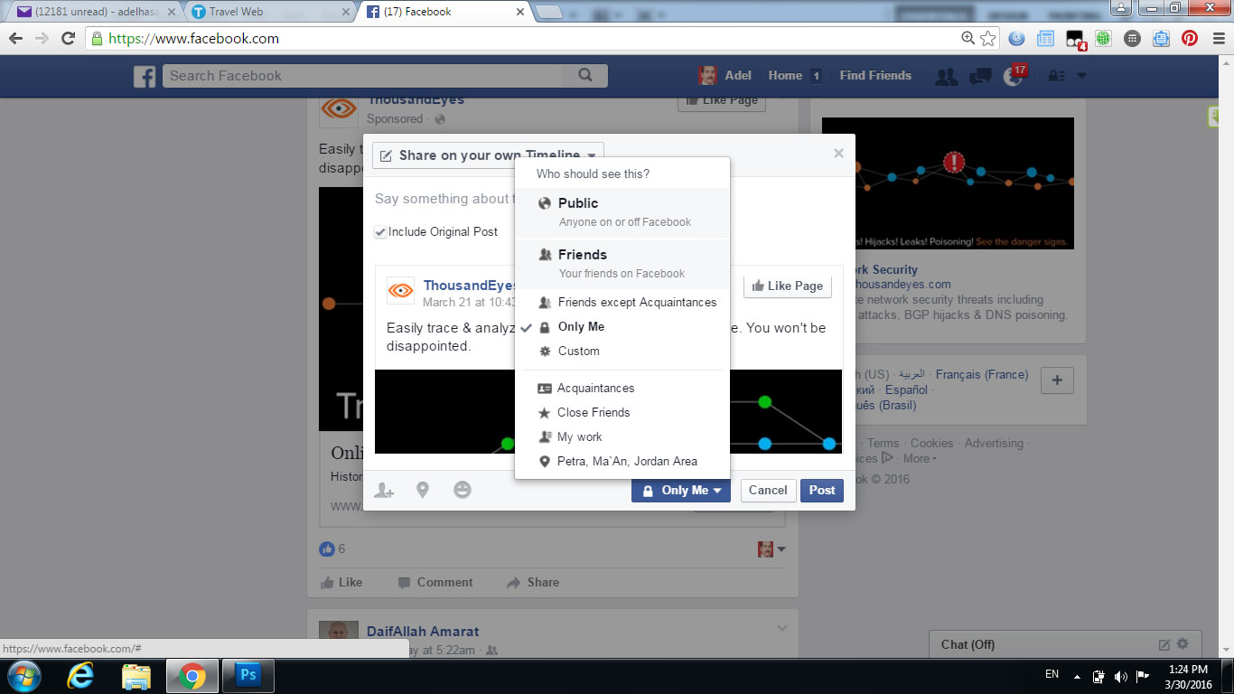

Please note the way the handle the birthdate calendar where the year and month day are showing in the same screen

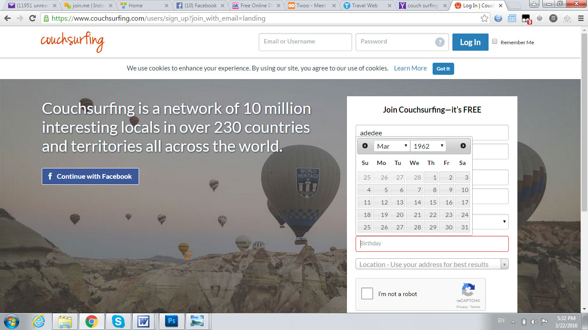

Set the page loading the style where the page load from the center to side for both the page and the travfeed and other pages for the whole page from.

Please test for, if the user enter the wrong Email or password, as of now the site do not inform the user what to do nor instruct the user of the problem. Check other site to what they and perform the same plz

Please Note, I moved the connect to facebook icon on the top of the signin boxes to allow to see it better when we do bootstrap over the Mobil screen but notice the OR need to be transport circle where any thing behind will show..
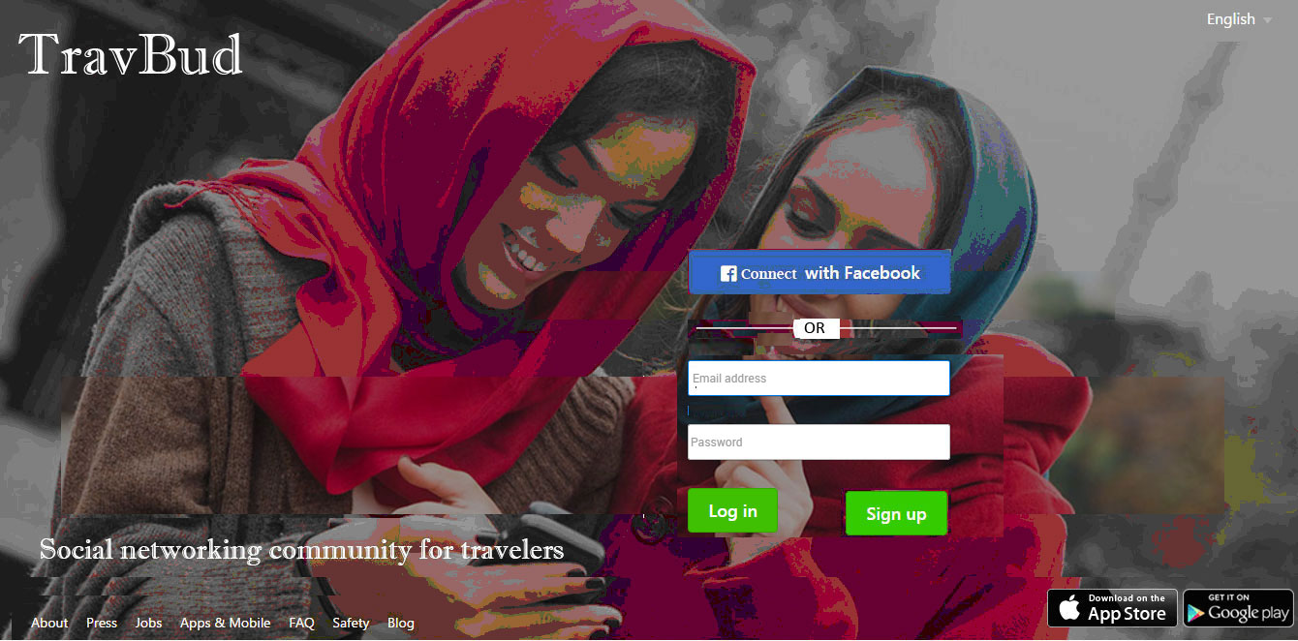

Please note the X to allow the member to close the screen if want to back to previous page, Also we can use the X to close the forget pass window.

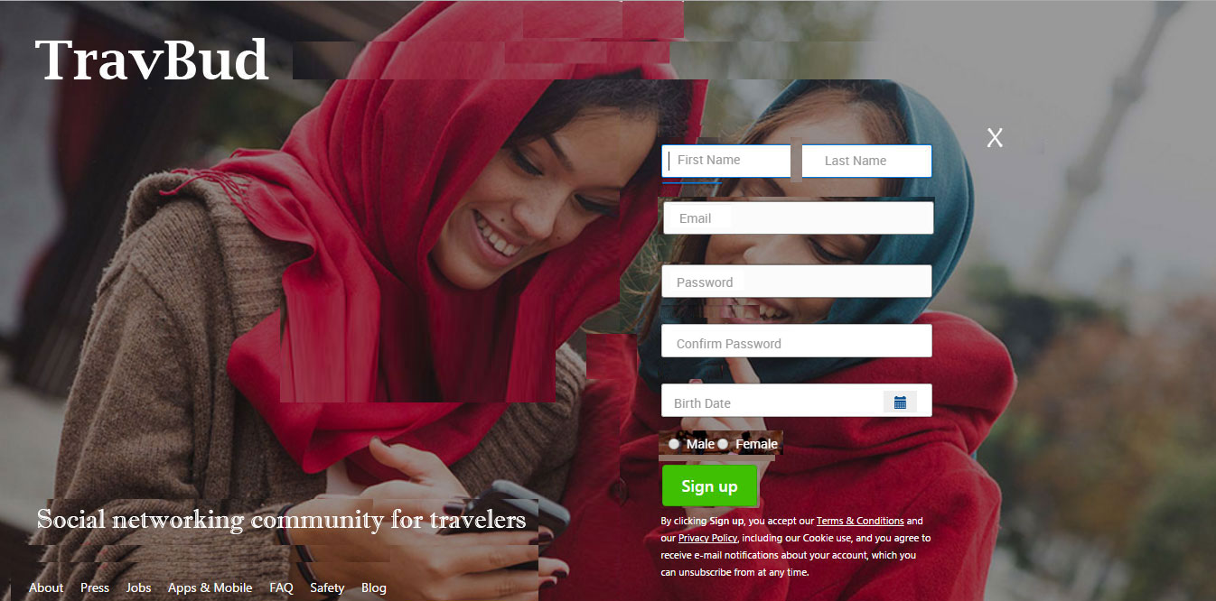
Please check the progress timer on the Mobil as of now it shows horizontally rather than being vertically.

Please Note to have the field Name is bold, we need to use darker color than the field text but we need to use the same color throughout the website to maintain consistey.
Notice the gray shade around the fields box.
Notice the progress timing that hold more information about the section. The one on the top that show each page that was compeleted e.i signup, profile, interest, photo, done
Please include the green check when the field is filled correctly and include a red X when is not filled correctly.
Allow member to set privacy for birthdate and Mobil num
For the Caption use adding two numbers and allow the member to put the value in the box
For example you may say “Add 3 and 2” and the member put “5” in the check box and that is good to verify that not a spam. Use signal digit only

Use Create Account icon when the member is done fill the page rather than the Verify icon you are using now.
Pre set the Mobil num with the country code
Now for the city we may use the approach I suggested earlier or we may use the approach in the profile page put we need to have it done automatically some what. While the country automatically populate by extracting the country info from the city selection.

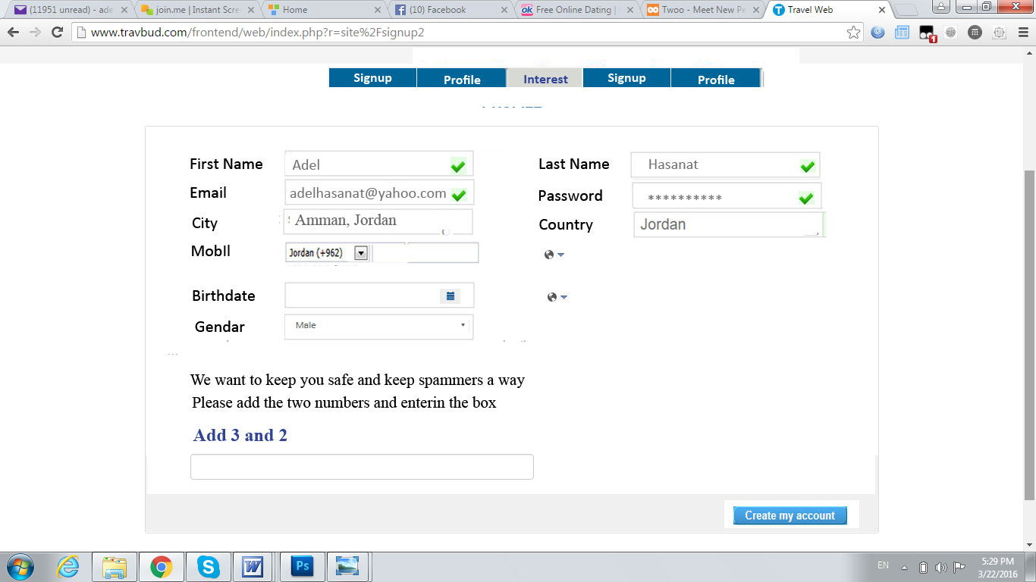

This the 2nd page in the registration process
We need to use selection as much as possible to allow for more easy way to fill the box
For example education, we may list the conmen degrees and high school listing for the user to choose from
For Occupations also we may list job allowing the member to choose from
For the languages also we can do a list
For interest we have to do check box kind of setup that allows the member to choose more that one item.
Please follow the design shown below for the hosting part

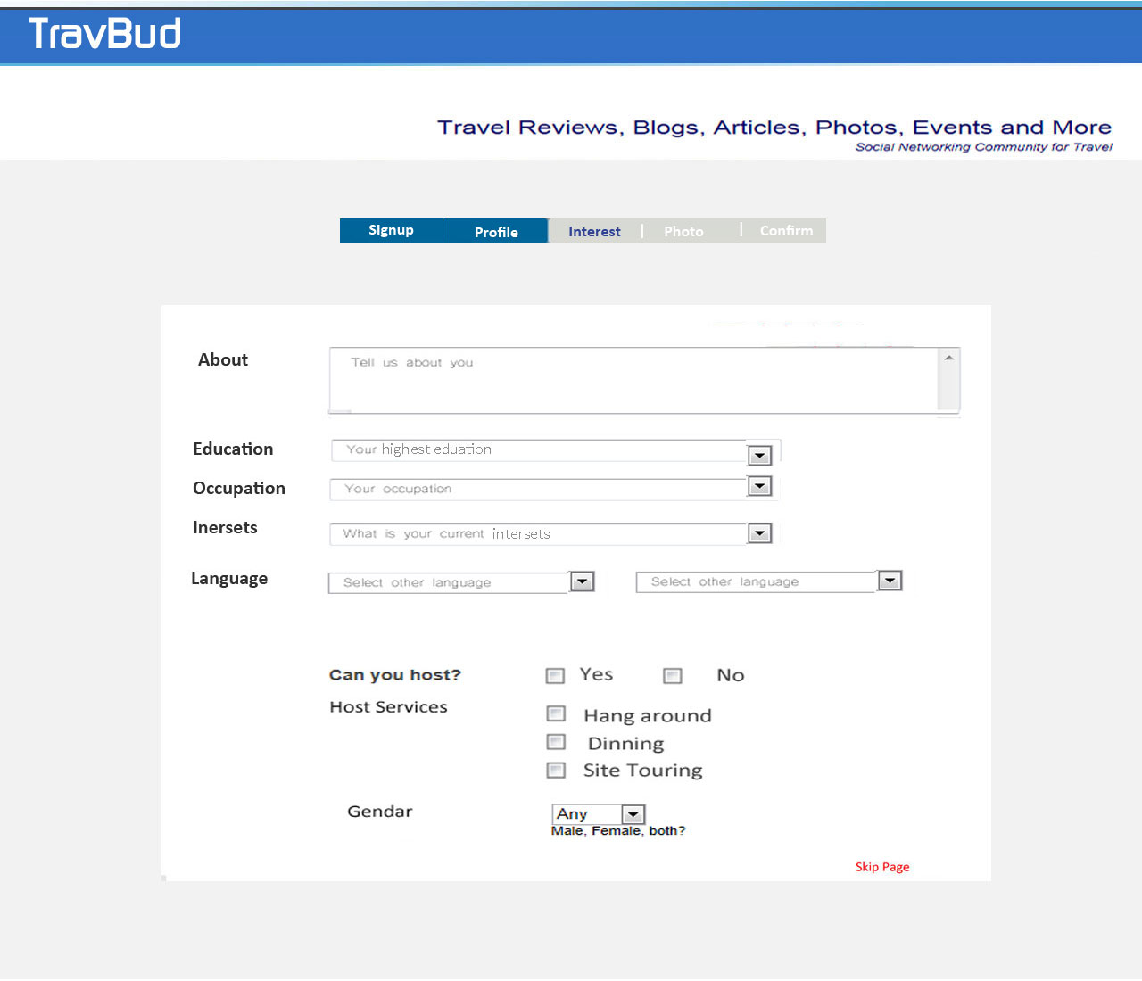

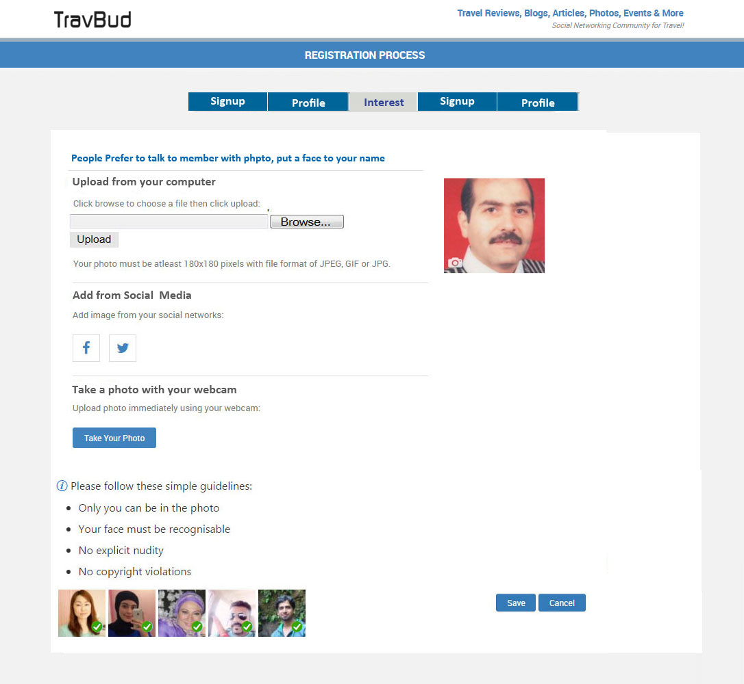

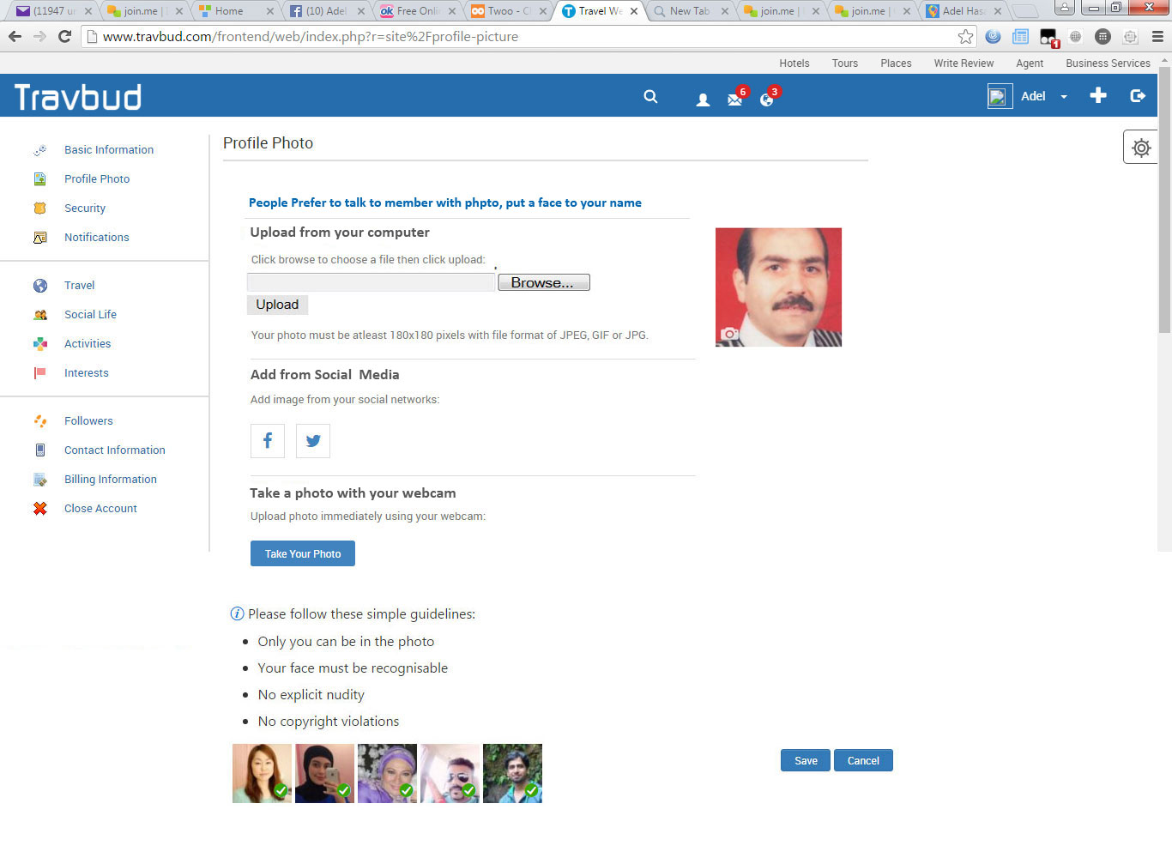

Please note the that 3 columns will look better and different from FB
Please note the look of the photo, gallery, post, saved and wall Graphic Design look you may check Wayn.com
Please use the gray shadow level as shown in the image
Please use more bold and bigger font for the photo, friend …. As shown in the image
Please bay attention to divide the 3 columns by the gray shadow evenly Also the three columns will show the data column better in the Mobil
Please use simailer Map like in the image below.

Please use the following tabs look as shown below with lighter gray color.

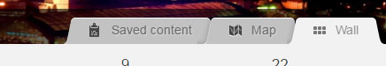

Check the about section to be similar to the following

